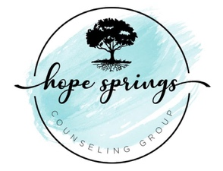
Hope Springs Counseling Group
2912 Green Street Marianna, Florida 32446
referrals@hopespringscg.com • (850) 372-4663

How to Partner with Hope Springs

  - Here at Hope Springs, we have a passion for healing of the emotional, mental, and behavioral health of Marianna and the surrounding communities. Our hope, and intention, is to serve the community by providing the greatest opportunities for pursuing health and wellness by partnering with other ministries and churches.
Pick how you partner:
In an effort to aid church leaders and pastors with congregational ministry, we have developed two main ways your church can partner with Hope Springs. With both options, our main desire is to accommodate you as you seek to accommodate the needs of your congregation. Therefore, we work to be as flexible and as helpful as possible as we share in this ministry with you.
- The main way we partner with churches is through our referral system. If your church is unable to grant financial aid for members of the congregation that are seeking mental health counseling, but you are still interested in connecting them to our office, we offer a $10 discount for any services when a church staff member provides our office with a referral sheet. The referral sheet provides us with the prospective client’s name, contact information, and any background information that may be available. Then, we reach out to the individual to discuss setting up an appointment. For information and/or access to the referral sheet, contact us at referrals@hopespringscg.com.
- If your church is interested in granting financial aid to the members of your congregation, you can set up a system in which you would pay for a portion of each counseling sessions for a set period of time (e.g. Paying 50% of the expense for 6 sessions, paying in full for 4, etc.). This process is completed with the referral sheet mentioned above, but financial aid is described at the bottom of the sheet.

Self-pay options serve as a substitute for insurance reimbursement. Most insurance companies require diagnosis by the first or second session and a certain level of documentation. When the church meets this need instead, the clients are able to attend counseling in an open format that is more flexible and not limited by stipulations set by insurance policies.

